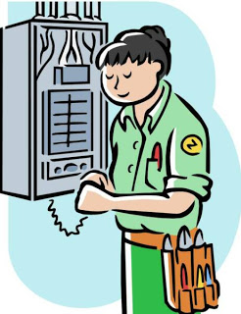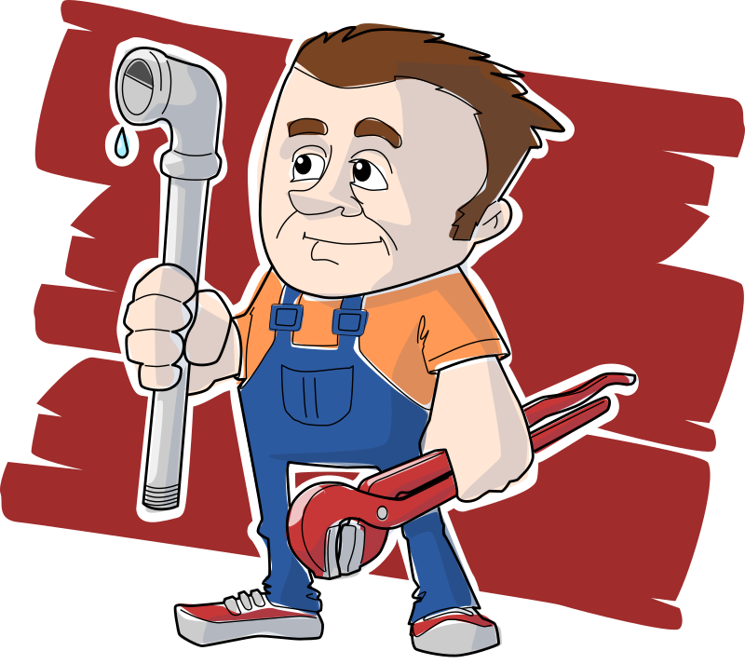

HANDS-ON ELECTRICAL AND PLUMBING MAINTENANCE
TRAINING PROVIDED BY TERO
JUNE 20, 21, 22, 2017
8:00 a.m. – 4:30 p.m.
Located at the Government Center
Training provided by: Training Service Assoc.
Deadline for registering for Training will be June 13, 2017 at 4:00 p.m.
If you have any questions, please call
634-2719 or 634-2716

